RAJALAKSHMI ENGINEERING COLLEGE
RAJALAKSHMI NAGAR, THANDALAM – 602 105

(REGULATION 2023)

LABORATORY RECORD NOTEBOOK

CS23432
DEPARTMENT OF ARTIFICIAL INTELLIGENCE AND MACHINE LEARNING

2024-2025
4th Semester
2116-231501022
2nd/AIML/FA
DILSHAD

RAJALAKSHMI ENGINEERING COLLEGE (AUTONOMOUS)
RAJALAKSHMI NAGAR, THANDALAM 602 105 BONAFIDE CERTIFICATE

DILSHAD
2116231501041
NAME REGISTER NO.

ACADEMIC YEAR 2024-25 SEMESTER- IV BRANCH: AIML-B.Tech

This Certification is the Bonafide record of work done by the above student in the CS23432- Software Construction Laboratory during
the year 2024 2025.

Signature of Faculty -in Charge

Submitted for the Practical Examination held on

Internal Examiner External Examiner

INDEX

DILSHAD
FA
AIML
Name: Branch: Sec: Roll no: 231501041
s.  No. | Date | TITLE | Page No. | Teacher's Signature  / Remarks
1. | 8/2/25 | Azure DevOps Environment Setup
2. | 15/2/25 | Azure DevOps Project Setup and User Story Management
3. | 22/2/25 | Setting Up Epics, Features, and User Stories for Project Planning
4. | 1/3/25 | Sprint Planning
5. | 8/3/25 | Poker Estimation
6. | 22/3/25 | Designing Class and Sequence Diagrams for Project Architecture
7. | 29/3/25 | Designing Architectural and ER Diagrams for Project Structure
8. | 5/4/25 | Testing – Test Plans and Test Cases
9. | 12/4/25 | Load Testing and Performance Testing
10. | 19/4/25 | Github: Project Structure & Naming Conventions

AZURE DEVOPS ENVIRONMENT SETUP

EXP NO: 1
DATE:

Aim:
Create Epic, Features, User Stories, Task
To set up and access the Azure DevOps environment by creating an organization through the Azure portal.

INSTALLATION
- Open your web browser and go to the Azure website: https://azure.microsoft.com/en-us/get- started/azure-portal.
Sign in using your Microsoft account credentials.
If you don't have a Microsoft account, you can create one here: https://signup.live.com/?lic=1

- Azure home page

- Open DevOps environment in the Azure platform by typing Azure DevOps Organizations in the search bar.

- Click on the My Azure DevOps Organization link and create an organization and you should be taken to the Azure DevOps Organization Home page.

Result:
Successfully accessed the Azure DevOps environment and created a new organization through the Azure portal.

AZURE DEVOPS PROJECT SETUP AND USER STORY MANAGEMENT

EXP NO: 2

Aim:
Create Epic, Features, User Stories, Task
To set up an Azure DevOps project for efficient collaboration and agile work management.

- Create An Azure Account

- Create the First Project in Your Organization
  - After the organization is set up, you’ll need to create your first project. This is where you'll begin to manage code, pipelines, work items, and more.
  - On the organization’s Home page, click on the New Project button.
  - Enter the project name, description, and visibility options:
Name: Choose a name for the project (e.g., LMS).
Description: Optionally, add a description to provide more context about the project. Visibility: Choose whether you want the project to be Private (accessible only to those invited) or Public (accessible to anyone).
  - Once you’ve filled out the details, click Create to set up your first project.

- Once logged in, ensure you are in the correct organization. If you're part of multiple organizations, you can switch between them from the top left corner (next to your user profile). Click on the Organization name, and you should be taken to the Azure DevOps Organization Home page.

- Project dashboard

- To manage user stories:
  - From the left-hand navigation menu, click on Boards. This will take you to the main Boards
page, where you can manage work items, backlogs, and sprints.
  - On the work items page, you'll see the option to Add a work item at the top. Alternatively, you can find a + button or Add New Work Item depending on the view you're in. From the Add a work item dropdown, select User Story. This will open a form to enter details for the new User Story.

Result:

setup.

Successfully created an Azure DevOps project with user story management and agile workflow

SETTING UP EPICS, FEATURES, AND USER STORIES FOR PROJECT PLANNING

EXP NO: 3
Aim:
Create Epic, Features, User Stories, Task
To learn about how to create epics, user story, features, backlogs for your assigned project.

Create Epic, Features, User Stories, Task

- Fill in Epics

- Fill in Features

- Fill in User Story Details

Result:
Thus, the creation of epics, features, user story and task has been created successfully.

SPRINT PLANNING

EXP NO: 4
Aim:
Create Epic, Features, User Stories, Task
To assign user story to specific sprint for the Academic Performance Evaluation Project.

Sprint Planning Sprint 1

Sprint 2

Sprint 3

Sprint 4

Result:
The Sprints are created for SMS/MMS Sending Project.

POKER ESTIMATION

EXP NO: 5

Aim:
Create Epic, Features, User Stories, Task
Create Poker Estimation for the user stories Academic Performance Evaluation Project.

Poker Estimation

Result:
The Estimation/Story Points is created for the project using Poker Estimation.

DESIGNING CLASS AND SEQUENCE DIAGRAMS FOR PROJECT ARCHITECTURE

EXP NO: 6

Aim:
Create Epic, Features, User Stories, Task
To Design a Class Diagram and Sequence Diagram for the given Project.

6A. Class Diagram

6B. Sequence Diagram

Result:
The Class Diagram and Sequence Diagram is designed Successfully for the SMS/MMS Sending Project
DESIGNING ARCHITECTURAL AND ER DIAGRAMS FOR PROJECT STRUCTURE

EXP NO: 7

Aim:
Create Epic, Features, User Stories, Task
To Design an Architectural Diagram and ER Diagram for the given Project.

7A. Architectural Diagram

7B.ER Diagram

Result:
Creator

The Architecture Diagram and ER Diagram is designed Successfully for the Music Playlist Batch

TESTING – TEST PLANS AND TEST CASES

EXP NO: 8
Aim:
Create Epic, Features, User Stories, Task
Test Plans and Test Case and write two test cases for at least five user stories showcasing the
happy path and error scenarios in azure DevOps platform.

SMS/Text Messaging Service - Test Plans
Here's the test plan, incorporating your user stories and providing a structure for testing in Azure DevOps:
USER STORIES
• As an academic administrator, I want the system to automatically evaluate student CGPAs against program requirements (ID: APE01).
• Administrators should see evaluation results (Good Standing, Warning, Probation, Dismissal) for each student (ID: APE02).
• Students and advisors receive notifications when academic status changes (ID: APE03).
• The system should enforce minimum CGPA requirements (e.g., 2.0 for Good Standing) (ID: APE04).
• Users can view Major CGPA separately from Overall CGPA (ID: APE05).
• Advisors can create academic improvement plans for at-risk students (ID: APE06).
• The system should track completion of academic improvement plan requirements (ID: APE07).
• Administrators can override automatic status determinations in special cases (ID: APE08).
• The system should generate reports of students in each academic status category (ID: APE09).
• The system should support different evaluation criteria by degree program (ID: APE10).
Test Suites
Test Suite Organization in Azure DevOps:
- TS01 - CGPA Evaluation Process (ID: 201)
- TS02 - Course Performance Analysis (ID: 202)
- TS03 - Academic Status Determination (ID: 203)
- TS04 - Status-Based Interventions (ID: 204)
- TS05 - Threshold Configuration (ID: 205)
- TS06 - Rules Transparency (ID: 206)
Test Cases
Test Suite: TS01 - CGPA Evaluation Process (ID: 201)
- TC01 - Successful Annual CGPA Evaluation (ID: 301)
  - Action:
    - Configure system for annual evaluation
    - Load test data for 500 students
    - Trigger annual evaluation process
    - Check evaluation results
  - Expected Results:
    - Process completes within 15 minutes
    - All 500 students are evaluated
    - Correct status assigned based on CGPAs
    - Evaluation timestamp recorded
  - Type: Happy Path
- TC02 - Evaluation with Missing Data (ID: 302)
  - Action:
    - Create test student with missing CGPA data
    - Trigger evaluation process
    - Check system response
  - Expected Results:
    - System flags incomplete records
    - Evaluation continues for other students
    - Error log created for missing data
  - Type: Error Path
Test Suite: TS02 - Course Performance Analysis (ID: 202)
- TC03 - Core Course Failure Detection (ID: 303)
  - Action:
    - Create test student with failing core course grade
    - Run course performance analysis
    - Check alert generation
  - Expected Results:
    - System detects core course failure
    - Advisor alert generated within 1 hour
    - Student record updated with failure flag
  - Type: Happy Path
- TC04 - Prerequisite Validation (ID: 304)
  - Action:
    - Attempt to register student for course without prerequisites
    - Check system response
  - Expected Results:
    - Registration blocked
    - Clear error message displayed
    - Missing prerequisites listed
  - Type: Error Path
Test Suite: TS03 - Academic Status Determination (ID: 203)
- TC05 - Automatic Probation Assignment (ID: 305)
  - Action:
    - Create test student with CGPA below probation threshold
    - Trigger status determination
    - Check status assignment
  - Expected Results:
    - Probation status assigned within 5 minutes
    - Probation letter generated
    - Advisor notified
  - Type: Happy Path
- TC06 - Status Override Process (ID: 306)
  - Action:
    - Attempt status override without proper authorization
    - Check system response
  - Expected Results:
    - Override attempt rejected
    - Security alert generated
    - Audit log entry created
  - Type: Error Path
Test Suite: TS04 - Status-Based Interventions (ID: 204)
- TC07 - Probation Workflow Execution (ID: 307)
  - Action:
    - Assign probation status to test student
    - Monitor automated workflow
  - Expected Results:
    - All probation steps completed within 24 hours
    - Mandatory advising session scheduled
    - Student notification sent
  - Type: Happy Path
- TC08 - Dismissal Case Creation (ID: 308)
  - Action:
    - Create test student meeting dismissal criteria
    - Trigger evaluation process
  - Expected Results:
    - Dismissal case file created
    - Registrar notified
    - Appeal process documented
  - Type: Happy Path
Test Suite: TS05 - Threshold Configuration (ID: 205)
- TC09 - CGPA Threshold Update (ID: 309)
  - Action:
    - Log in as administrator
    - Update program CGPA threshold
    - Verify change persistence
  - Expected Results:
    - Change saved successfully
    - Version history updated
    - Affected users notified
  - Type: Happy Path
- TC10 - Invalid Threshold Entry (ID: 310)
  - Action:
    - Attempt to set CGPA threshold above 4.0
    - Check system response
  - Expected Results:
    - Change rejected
    - Validation error displayed
    - No change to existing threshold
  - Type: Error Path
Test Suite: TS06 - Rules Transparency (ID: 206)
- TC11 - Student Requirements Display (ID: 311)
  - Action:
    - Log in as test student
    - Access academic requirements view
  - Expected Results:
    - All program requirements displayed clearly
    - Current standing shown accurately
    - Mobile-responsive display
  - Type: Happy Path
- TC12 - Advisor Policy Access (ID: 312)
  - Action:
    - Log in as advisor
    - Search for academic policy
  - Expected Results:
    - Relevant policy documents returned
    - Search results within 2 seconds
    - Complete policy text available
  - Type: Happy Path

Test Cases

- Installation of test

- Running the test cases

- Recording the test case

- Creating the bug

Test case results

- Test report summary

  - Assigning bug to the developer and changing state

Progress report

- Changing the test template

- View the new test case template

Result:
The test plans and test cases for the user stories is created in Azure DevOps with Happy Path and
Error Path

LOAD TESTING AND PERFORMANCE TESTING

EXP NO: 9

Aim:
Create Epic, Features, User Stories, Task
To create an Azure Load Testing resource and run a load test to evaluate the performance of a target endpoint.

Load Testing

Steps to Create an Azure Load Testing Resource:
Before you run your first test, you need to create the Azure Load Testing resource:
- Sign in to Azure Portal
Go to https://portal.azure.com and log in.
- Create the Resource
  - Go to Create a resource → Search for “Azure Load Testing”.
  - Select Azure Load Testing and click Create.
- Fill in the Configuration Details
  - Subscription: Choose your Azure subscription.
  - Resource Group: Create new or select an existing one.
  - Name: Provide a unique name (no special characters).
  - Location: Choose the region for hosting the resource.
- (Optional) Configure tags for categorization and billing.
- Click Review + Create, then Create.
- Once deployment is complete, click Go to resource.

Steps to Create and Run a Load Test:
Once your resource is ready:
- Go to your Azure Load Testing resource and click Add HTTP requests > Create.
- Basics Tab
  - Test Name: Provide a unique name.
  - Description: (Optional) Add test purpose.
  - Run After Creation: Keep checked.
- Load Settings
  - Test URL: Enter the target endpoint (e.g., https://yourapi.com/products).
- Click Review + Create → Create to start the test.

Load Testing

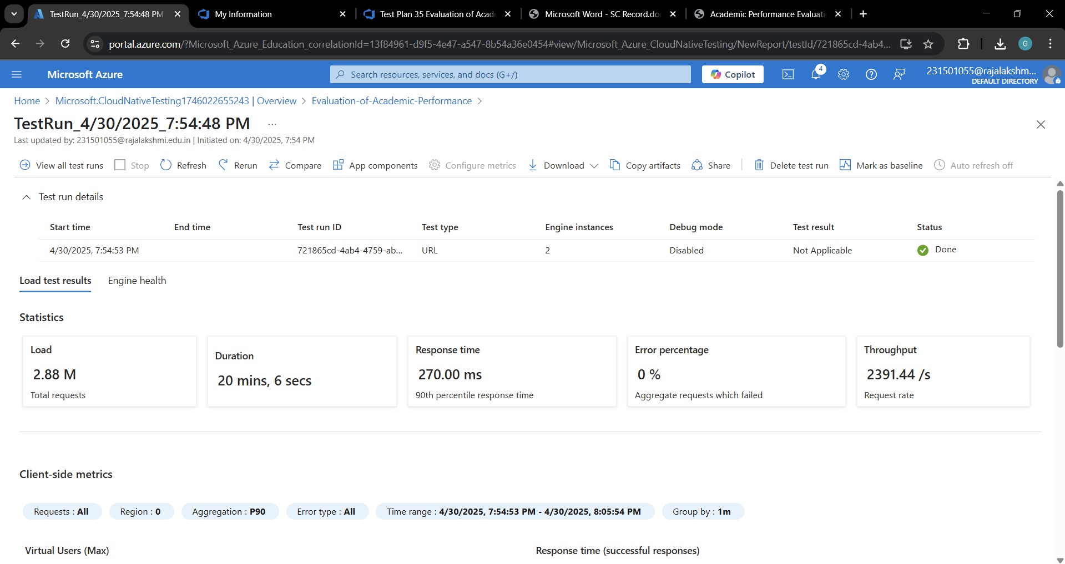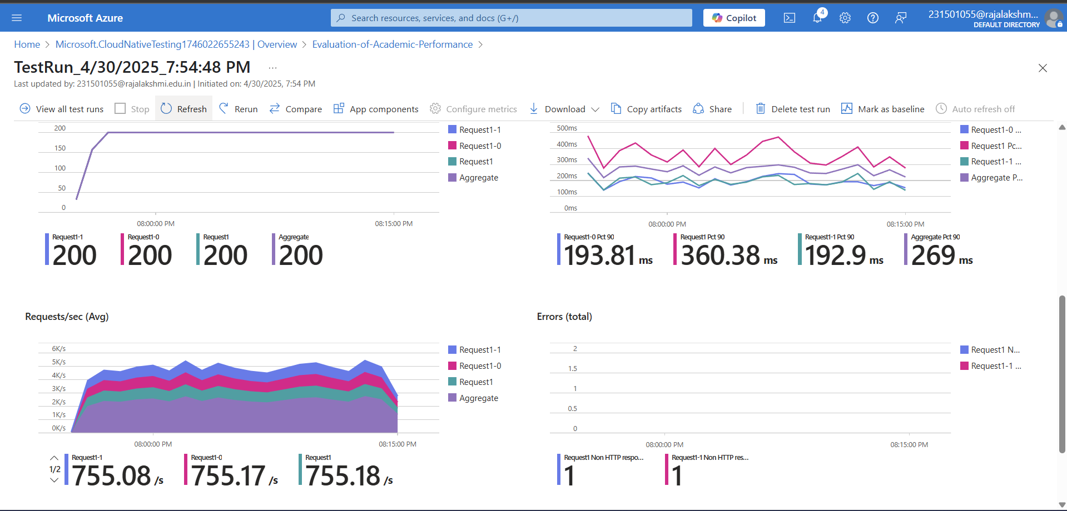
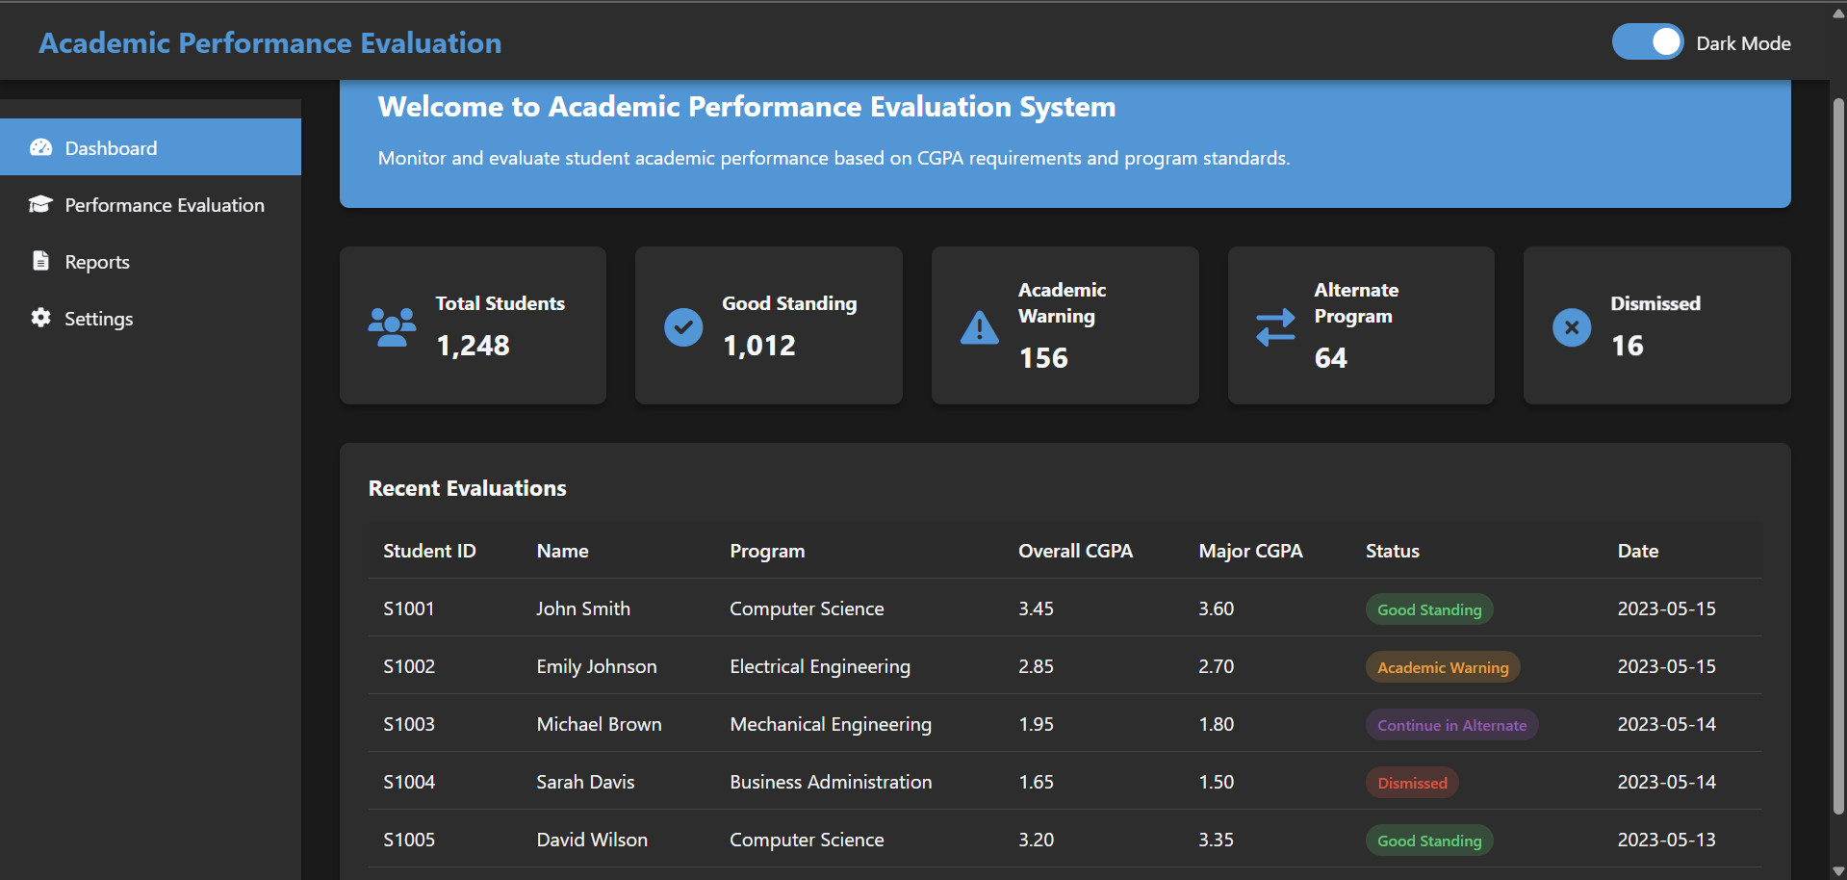

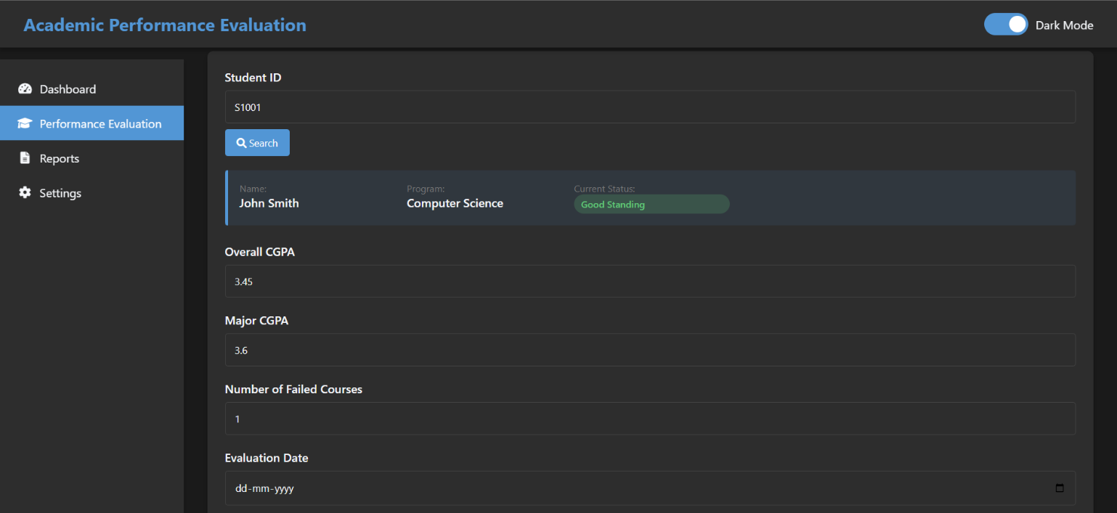

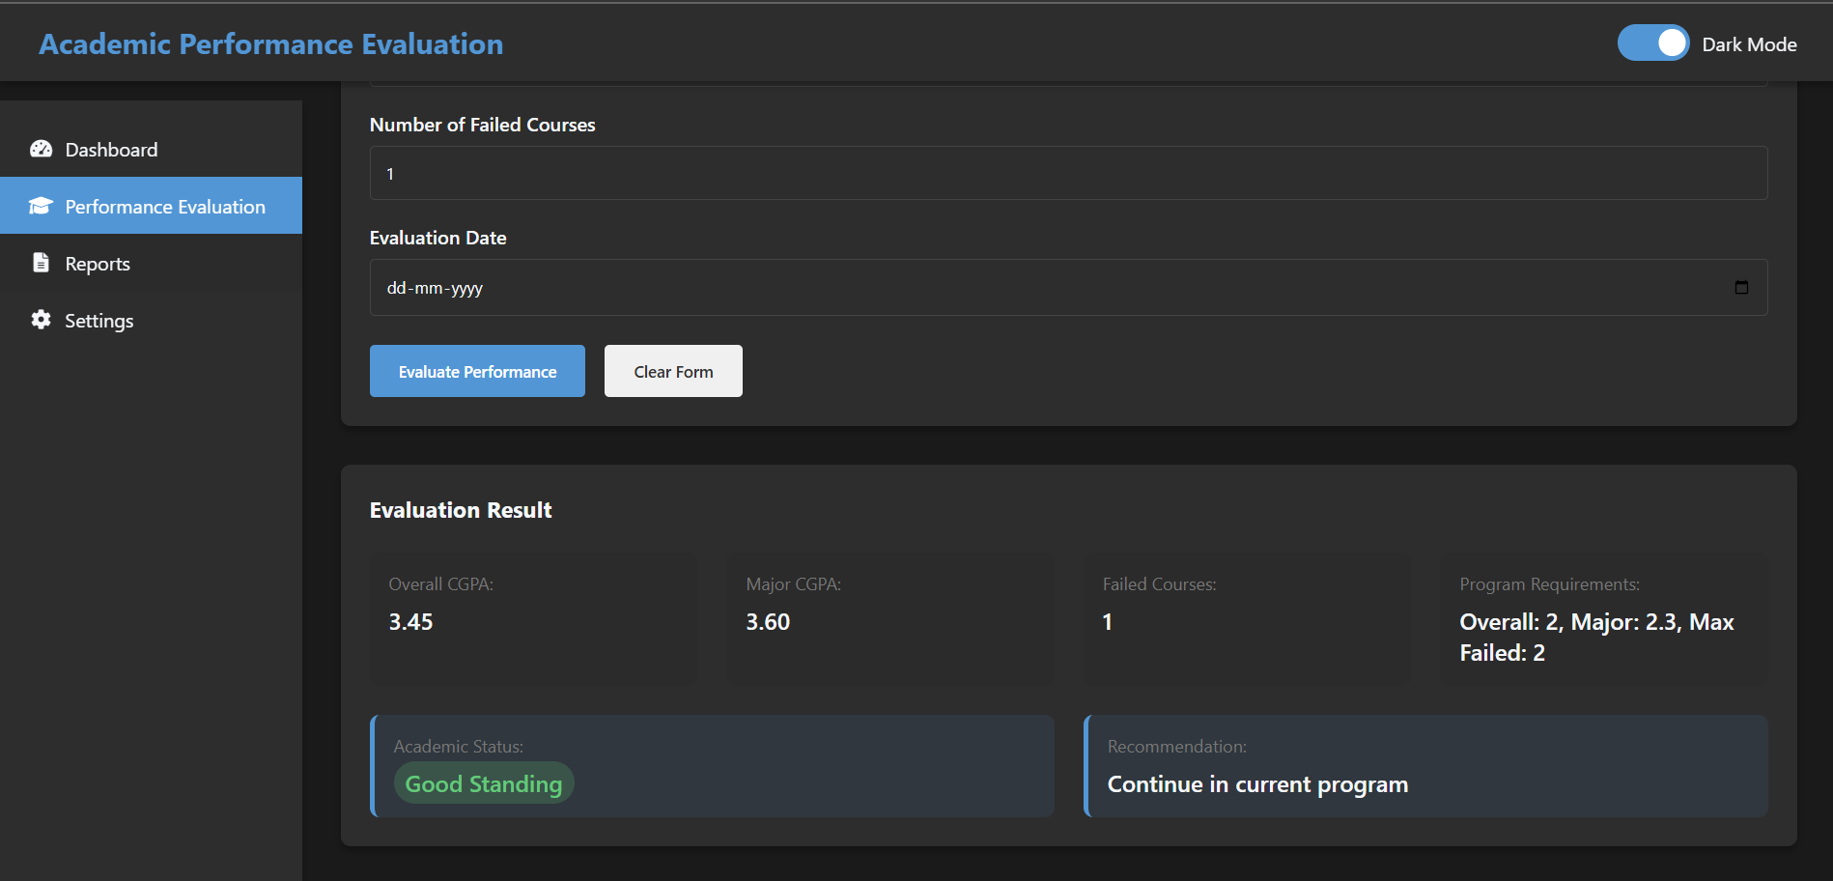

Result:
Successfully created the Azure Load Testing resource and executed a load test to assess the
performance of the specified endpoint.

GITHUB: PROJECT STRUCTURE & NAMING CONVENTIONS

EXP NO: 10

Aim:
Create Epic, Features, User Stories, Task
To provide a clear and organized view of the project's folder structure and file naming conventions, helping contributors and users easily understand, navigate, and extend the Academic Performance Evaluation System for effective and transparent assessment of student academic standing.

GitHub Project Structure
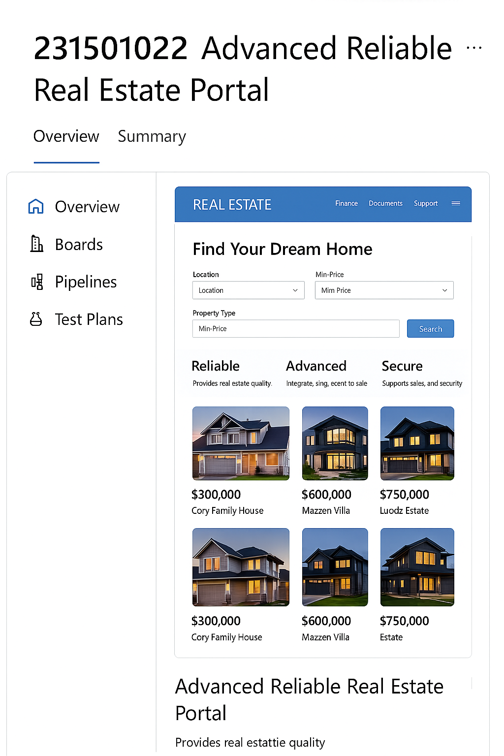

Result:
The GitHub repository clearly displays the organized project structure and consistent naming
conventions, making it easy for users and contributors to understand and navigate the codebase.

